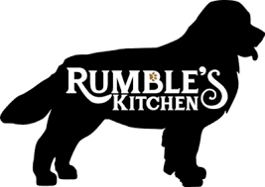

Saint Patrick’s Day
First Course:
Irish Soda Bread
Honey | Porridge Oats | Buttermilk
5

Irish Stew
Lamb | Bacon | Onions | Herbs
14

Main Course:
Corned Beef and Cabbage
Pork shoulder |Onion
Cabbage |Carrots |Mustard Sauce
20

Coddled Pork
Irish cider |Smoked Bacon
Potatoes |Carrots |Cabbage | Fresh Herbs
20

Ask your server about our drink and beer specials!!

