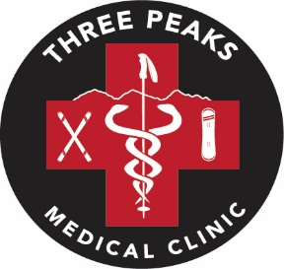
1st Annual Three Peaks Medical Clinic Golf Tournament

Registration Form

Monday August 15th, 2022
Sugarbush Resort Golf Club 10:00 am Shotgun

$600 per team/ $150 Individual. Entry Fee includes cart, range balls, BBQ Lunch, Tee Gift, On-Course contests and Division Prizes. Dinner, Awards and Silent Auction to follow at Rumble’s at Clay Brook.
Vegetarian Option available upon request.
Individual Hole Sponsorship for $500 available.
All Net Proceeds will go to the Clinic to cover start-up and annual operating needs.

Divisions: Men’s, Women’s and Mixed.

Please pay by check or cash day of tournament.

Player 1: Name: __________________________ Player 2: Name: __________________________
Email address: _____________________ Email address: ____________________________
Phone Number: ____________________ Phone Number: ___________________________

Player 3: Name: __________________________ Player 4: Name: __________________________
Email address: _____________________ Email address: ____________________________
Phone Number: ____________________ Phone Number: ___________________________
# of Vegetarian Dinner requests: ____
Hole Sponsorship Registration:

Name/Company: ____________________________
Wording for Sign: ___________________________
CC#_______________________________________
Exp Date: __________ CV Code: _________

Registration deadline is August 1, 2022.

All inquiries, please contact:
Chad Borofsky, Director, Sugarbush Ski Patrol 802 279 3593
John Parsons, Tournament Co-Chair 802 583 6521
Patrick Konvicka, Tournament Co-Chair 802 583 6596

Email completed form to Jparsons@sugarbush.com

